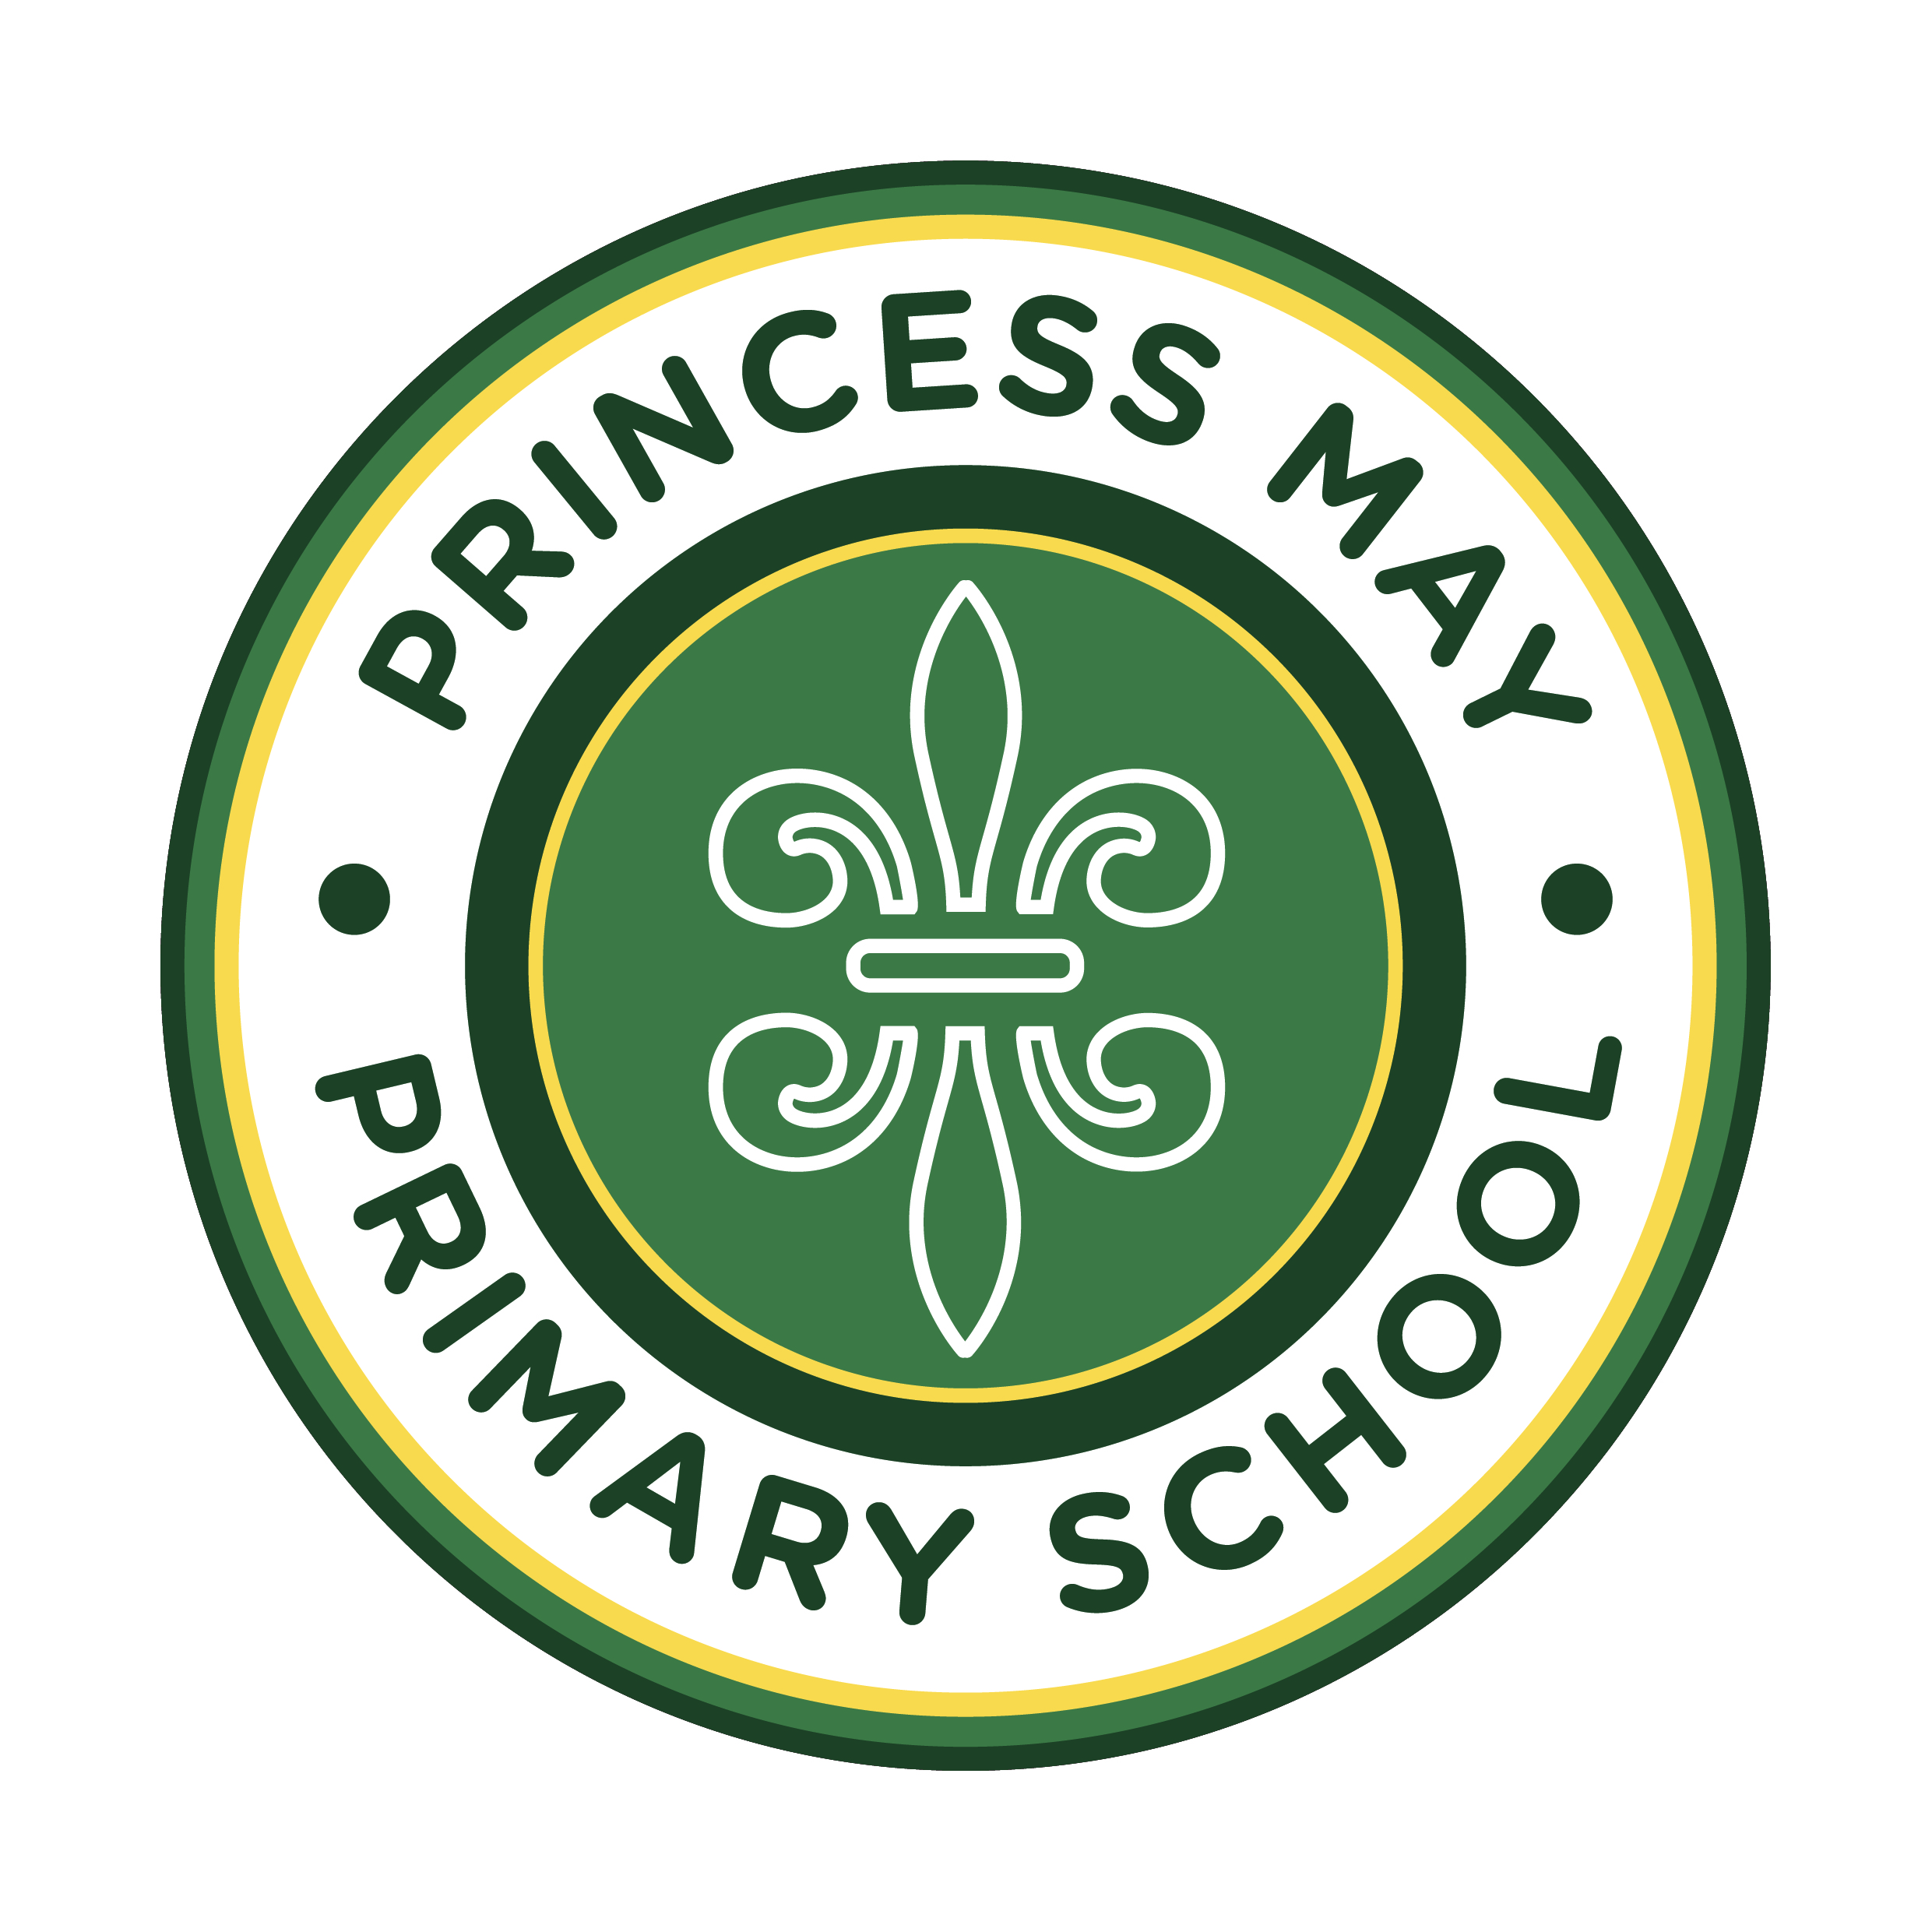
POLICY DOCUMENT
Social Media Code of Conduct for Parents
Princess May Primary School's expectations of parents and carers online — 2026–2027
Governing Body Representative (GBR) | Kristofer McGhee (Chair of Governors)
Signed by (GBR)
Date approved | Pending governing board approval
Next review due by | September 2027
Related policies | Complaints Procedure; Behaviour Policy; Online Safety Policy; Data Protection Policy
Aligned to | Data Protection Act 2018; UK GDPR; the Protection of Freedoms Act 2012; the Defamation Act 2013; the Malicious Communications Act 1988 and the Communications Act 2003; the Online Safety Act 2023; and the DfE's non-statutory guidance, Preventing and Tackling Bullying and Harassment of School Staff (July 2026)

Statement of intent
This policy applies to all year groups at Princess May Primary School, including the EYFS.
Princess May Primary School understands the benefits of using social media; however, if misused, the school community can be negatively affected. This can include individual pupils, groups or classes of pupils, staff, or the reputation of the school.
This code of conduct sets out clear procedures for how we expect parents to conduct themselves on social media and when using messaging apps, with regard to the school, its pupils and its staff. We ask that parents read this document and ensure that they always act in accordance with the expectations set out below, and with the school's whole-school approach to a respectful, calm and safe community for pupils and staff alike.
1. Legal framework
This document has due regard to all relevant legislation and statutory guidance, including but not limited to the following:
- the Data Protection Act 2018;
- the UK General Data Protection Regulation (UK GDPR);
- the Protection of Freedoms Act 2012;
- the Defamation Act 2013;
- the Malicious Communications Act 1988 and the Communications Act 2003; and
- the Online Safety Act 2023.
This document also has regard to the DfE's non-statutory guidance, Preventing and Tackling Bullying and Harassment of School Staff (July 2026), which identifies a school's parental code of conduct as one of the key policies schools should have in place to protect staff, alongside the Behaviour Policy and staff code of conduct.
This document operates in conjunction with the following school policies:
- Complaints Procedure;
- Behaviour Policy;
- Online Safety Policy; and
- Data Protection Policy.
2. Online safety and social media conduct
Our school expects parents to behave in a civilised manner online, and will not tolerate any of the following online behaviour:
- posting defamatory content about parents, pupils, the school or its employees;
- complaining about the school's values and methods on social media;
- posting content containing confidential information regarding the school or any members of its community, for example a complaint outcome;
- contacting school employees through social media, including requesting to 'follow' or 'friend' them, or sending them private messages;
- creating or joining private groups or chats that victimise or harass a member of staff, a pupil or groups of pupils, or the school in general; and
- posting images of any staff members or pupils without their prior consent.
Parents' social media usage will be in accordance with the school's Online Safety Policy. The school retains the right to request that any damaging material is removed from social media websites. If parents wish to raise a complaint, the school has a Complaints Procedure in place.
Breaches of this code of conduct will be taken seriously by the school and, in the event of illegal, defamatory or discriminatory content, breaches could lead to prosecution. Parents are instructed not to post anonymously or under an alias to evade the guidance given in this code of conduct.
Where illegal, threatening or harassing content is posted about a member of staff, the school will follow the approach set out in the DfE's guidance, Preventing and Tackling Bullying and Harassment of School Staff (July 2026), including seeking to have offensive content removed and, where appropriate, involving the police.
3. Online messaging
The school expects parents to use messaging apps, such as WhatsApp, for purposes beneficial to themselves and the school, and will not accept any of the following behaviour:
- sending abusive messages to fellow parents;
- sending abusive messages about members of staff, parents, pupils or the school;
- sharing confidential or sensitive information about members of staff, parents, pupils or the school;
- bringing the school or its staff into disrepute; and
- communicating on behalf of the school.
The school appreciates the simplicity and ease of instant messaging; keeping in contact outside of school can benefit the school community by keeping it closer. The school does not, however, condone parents sending messages about school matters as though they were a voice of authority for the school.
Should any problems arise from contact over messaging apps, the school will act quickly by contacting parents directly, to stop any issues continuing. The school can request a meeting with parents if any misconduct, such as sending abusive messages or posting defamatory content, occurs online. The Headteacher can request that 'group chats' are closed down should any problems continue between parents or parental bodies.
4. Photography and images
Parents may be permitted to take photos of their children at certain school events, such as sports day or a theatre production; however, parents may only take photos of their own children, and should only share photos of their own children on social media.
Parents must not take photos of other children, staff members or volunteers, nor post them on social media, without the consent of those within the images or, where applicable, their parents. During events outside of school, such as dropping children off at the school gate, or whilst visiting the school, parents must not take photos of any members of the school community, nor share these photos on social media.
In line with our Online Safety Policy, parents must not create, alter or share any digitally altered or AI-generated image or video (including so-called 'deepfakes') that depicts a pupil, member of staff or volunteer without their consent, whether or not the original image was taken lawfully. Such content, including where it is created or shared as a joke, will be treated as a serious breach of this policy and may be referred to the police, in line with our Online Safety Policy and Safeguarding and Child Protection Policy.
5. Responsibility
Parents are responsible for monitoring their own use of social media and online messaging, and must adhere to the Social Media Code of Conduct for Parents at all times. Parents are also responsible for supporting the school by monitoring their children's use of social media and online messaging, and for supporting their children in adhering to the Pupil Code of Conduct.
6. Reporting and responding to concerns
In line with the DfE's whole-school approach to preventing bullying and harassment, the school will ensure that reporting routes for parents, pupils and staff are clear and accessible, and that incidents involving parents online, such as through email or social media, are recorded and dealt with promptly.
Any parent with a concern about the school should raise it, in the first instance, with the relevant member of staff or the Headteacher, in a respectful way that promotes working in partnership and avoids conduct that could be considered abusive.
Any member of staff experiencing bullying or harassment from a parent online should report this to the Headteacher or a member of the senior leadership team without delay, and may also seek support through their recognised trade union. The school will respond consistently, promptly and assertively to protect staff wellbeing and safety.
7. Home-school agreement
A home-school agreement is a statement explaining:
- the school's aims and values;
- the school's responsibilities towards its pupils who are of compulsory school age;
- the responsibility of each pupil's parents; and
- what the school expects of its pupils.
All maintained schools and academies are required to publish a home-school agreement and associated parental declaration.
Schools must take reasonable steps to ensure that all registered parents of pupils sign the parental declaration to indicate that they understand and accept the contents of the home-school agreement.
8. Monitoring and review
This policy is reviewed annually by the Headteacher and the governing board. Any changes made to this policy will be communicated to parents.

