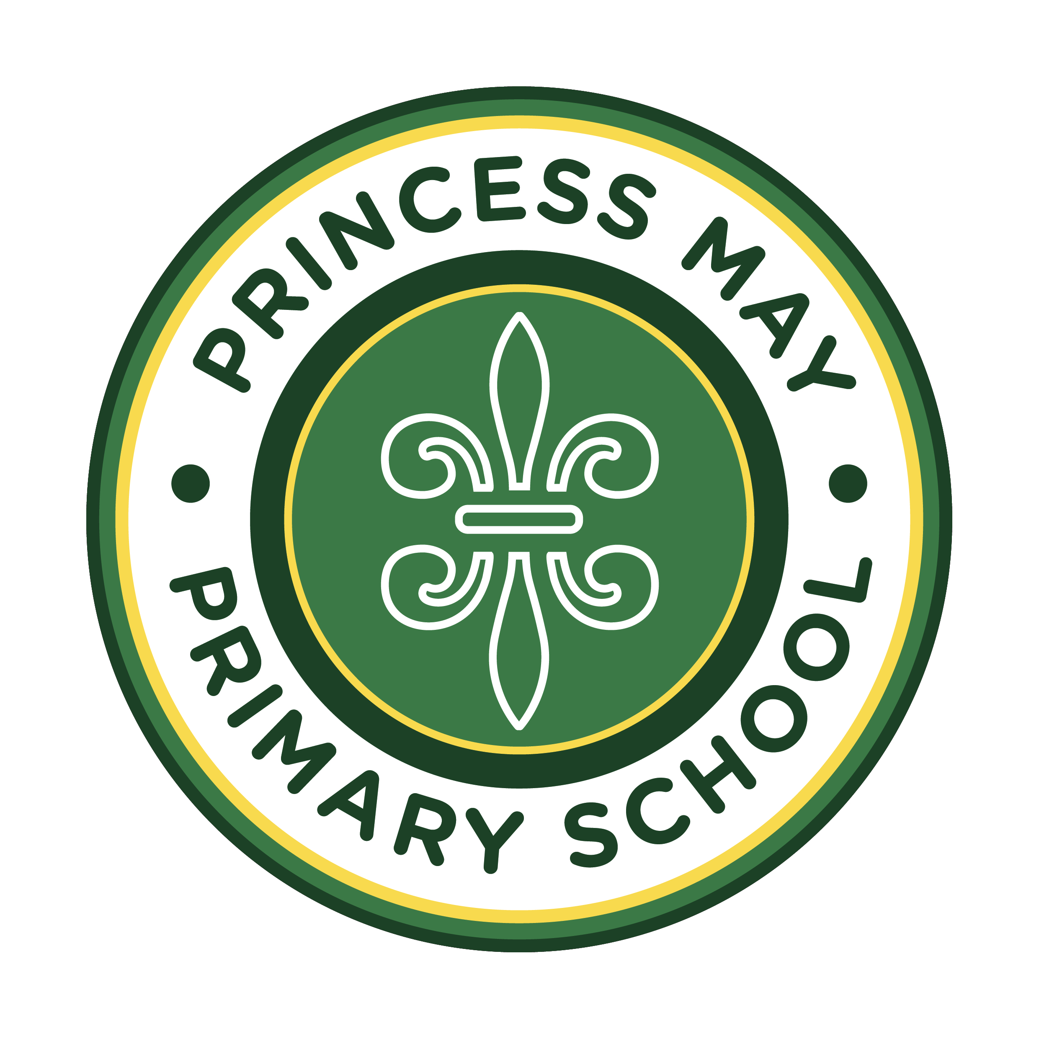
POLICY DOCUMENT
Supporting Pupils with Medical Conditions Policy
Princess May Primary School's approach to supporting pupils with medical conditions — 2026–2027
Governing Body  Representative (GBR) | Kristofer McGhee (Chair of Governors)
Signed by (GBR) | 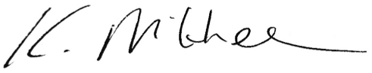
Date approved | 4 September 2026
Next review due by | September 2027
Related policies | First Aid Policy; Allergy Policy; Accessibility Plan; Equality Information and Objectives; Safeguarding and Child Protection Policy; SEND Policy; Complaints Policy
Aligned to | Section 100, Children and Families Act 2014; DfE statutory guidance Supporting Pupils at School with Medical Conditions; and the direction of the DfE consultation response Supporting Pupils with Medical Conditions at School (July 2026)

1. Policy statement
This policy aims to ensure that:
- pupils, staff and parents understand how our school supports pupils with medical conditions; and
- pupils with medical conditions are properly supported to access the same education as other pupils, including school trips and sporting activities.
The governing board will implement this policy by:
- making sure sufficient staff are suitably trained;
- making staff aware of a pupil's condition, where appropriate;
- making sure cover arrangements are in place so support is always available;
- providing supply teachers with appropriate information about the policy and relevant pupils; and
- developing and monitoring Individual Healthcare Plans (IHPs).
The named senior leader with responsibility for implementing this policy is Hannah Blunden (SENCO).
2. Legislation, statutory responsibilities and the direction of travel
This policy meets the requirements of section 100 of the Children and Families Act 2014, which places a duty on governing boards to make arrangements for supporting pupils with medical conditions, and is based on the Department for Education's statutory guidance, Supporting Pupils at School with Medical Conditions.
In July 2026, the Department for Education published its response to a consultation on strengthening this statutory guidance. The government has confirmed it will revise the guidance, working further with the Department of Health and Social Care to clarify the respective roles of education and health professionals, before publishing an updated version; this policy reflects the confirmed direction of travel in the meantime. Confirmed changes include: oversight of the policy sitting with a named senior leader, rather than a named governor; an expectation that the policy is reviewed at least annually, with a serious incident or near miss acting as a prompt to consider whether review is needed, rather than triggering an automatic review; clearer criteria for when a pupil needs an IHP; and confirmation that an IHP is the school's record of how it will deliver the care and action plans, and advice, provided by a pupil's clinicians — rather than a clinical document in its own right. The government has also confirmed it will separately publish statutory guidance on allergy safety, reflecting a new duty introduced by the Children's Wellbeing and Schools Act 2026; our approach to allergies is set out in the school's Allergy Policy.
The government has also confirmed its intention to extend the statutory duty to make arrangements for supporting pupils with medical conditions to further education and post-16 providers, non-maintained special schools, and independent schools, through future legislation; this does not change Princess May's existing duty as a maintained primary school, which already applies under section 100.
3. Roles and responsibilities
The governing board
The governing board has ultimate responsibility for making arrangements to support pupils with medical conditions, and ensures that sufficient staff have received suitable training and are competent before taking on this responsibility.
The Headteacher and named senior leader (SENCO)
The Headteacher and the named senior leader responsible for this policy, Hannah Blunden (SENCO), will:
- make sure all staff are aware of this policy and understand their role in implementing it;
- ensure a sufficient number of trained staff are available to deliver against all IHPs, including in contingency and emergency situations;
- take overall responsibility for the development of IHPs;
- make sure school staff are appropriately insured, and aware that they are insured, to support pupils in this way;
- contact the school nursing service for any pupil with a medical condition that may require support in school but has not yet been brought to the school's attention; and
- ensure systems are in place for obtaining and keeping up to date information about a child's medical needs.
Staff
Supporting pupils with medical conditions is not the sole responsibility of one person; any member of staff may be asked to provide support, including administering medicines, although they will not be required to do so. Staff who take on this responsibility will receive sufficient and suitable training and achieve the necessary competency first. Teachers take into account the needs of pupils with medical conditions that they teach, and all staff know what to do and respond appropriately when they become aware that a pupil needs help; it is the responsibility of teachers to check the medical register regularly for updates to the medical needs of children they work with.
Parents
Parents will:
- provide the school with sufficient and up-to-date information about their child's medical needs;
- be involved in the development and review of their child's IHP, and may be involved in its drafting; and
- carry out any agreed action, such as providing medicines and equipment.
Pupils
Pupils are often best placed to explain how their condition affects them, and should be fully involved in discussions about their medical support needs, contributing as much as possible to their IHP; they are also expected to comply with it.
School nurses and other healthcare professionals
The school nursing service (Homerton University Hospital Nursing Team) will notify the school when a pupil has been identified as having a medical condition requiring support in school, wherever possible before the pupil starts. Healthcare professionals, such as GPs and paediatricians, liaise with the school nurses and notify them of pupils identified as having a medical condition.
4. Equal opportunities and wellbeing
Princess May Primary School actively supports pupils with medical conditions to participate in school trips, visits and sporting activities, rather than preventing them from doing so. We consider what reasonable adjustments are needed to enable full and safe participation, and carry out risk assessments so that planning takes account of any steps needed, consulting pupils, their parents and any relevant healthcare professionals.
We recognise that medical conditions can affect a pupil's emotional wellbeing, confidence and sense of belonging, as well as their physical health, and that pupils with medical conditions can be at increased risk of anxiety, social isolation or bullying — particularly where they feel singled out from their peers. Staff developing and reviewing a pupil's IHP will consider their wellbeing alongside their physical safety, and any concerns about bullying related to a pupil's medical condition will be addressed through our Anti-Bullying Policy.
5. Being notified that a child has a medical condition
When the school is notified that a pupil has a medical condition — whether a new diagnosis or a change in needs — the SENCO will co-ordinate a meeting to discuss the child's needs and identify a member of staff to support the pupil, where appropriate. If a child needs medication in school before an IHP is written, parents will sign a permission to administer medication form (Appendix 2).
A meeting will then be held between parents, the child (if appropriate), relevant healthcare professionals and key school staff to decide whether an IHP is needed. Where one is needed, the school nurse will help develop it, identify any training needs arising from it, and sign off the plan to confirm staff are competent to deliver any medication. The IHP is then implemented and circulated to relevant staff, and reviewed annually, or when the child's condition changes, at the initiation of parents or healthcare professionals.
The school will make every effort to have arrangements in place within 2 weeks, or by the start of the relevant term for pupils new to the school.
6. Individual healthcare plans
The Headteacher has overall responsibility for the development of IHPs, delegated to Hannah Blunden (SENCO). Reflecting the government's July 2026 consultation response, a pupil will have an IHP where: they have a long-term medical condition, such as an allergy, which has a functional impact on them in school; they are at risk of harm as a result of their medical condition; and they require arrangements that are additional to, or different from, those made generally. Not every pupil with a medical condition will need an IHP — this will be agreed with a healthcare professional and parents, based on evidence; if there is no consensus, the Headteacher will make the final decision.
An IHP is the school's record of how it will deliver the care plans, action plans and advice provided by a pupil's clinicians — it is not a clinical document, and staff will not attempt to summarise or make clinical judgements about the advice provided by healthcare professionals. Rather, it brings together, in one place, the information the school needs to support the pupil safely and consistently. Plans are drawn up in partnership with the school, parents and a relevant healthcare professional, with the pupil involved wherever appropriate, and are reviewed at least annually, or sooner if there is evidence the pupil's needs have changed.
Where a pupil has SEN but does not have a statement or EHC plan, this is mentioned in the IHP; where a pupil has an EHC plan, the IHP does not override or duplicate the provision set out in Section G of that plan, which takes precedence.
The level of detail in an IHP depends on the complexity of the pupil's needs, and will typically record:
- the medical condition, its triggers, signs, symptoms and treatments;
- the pupil's resulting needs, including medication, other treatments, equipment, dietary requirements and environmental considerations;
- specific support for the pupil's educational, social and emotional needs, including how absences will be managed;
- the level of support needed, including in an emergency, and who is responsible for providing it, their training needs and cover arrangements;
- who in school needs to be aware of the pupil's condition and the support required;
- arrangements for written parental and Headteacher permission for medication to be administered, or self-administered by the pupil;
- arrangements for school trips or other activities outside the normal timetable, including any risk assessment;
- who is entrusted with information about the pupil's condition, where confidentiality issues are raised; and
- what to do in an emergency, including who to contact and contingency arrangements.
7. Managing medicines
Prescription medicines will only be administered at school where it would be detrimental to the pupil's health or attendance not to do so, and where we have the parents' written consent (Appendix 2). Pupils under 16 will not be given medicine containing aspirin unless prescribed by a doctor; anyone giving a pupil any medication will first check maximum dosages and when the previous dose was given, and parents will always be informed.
The school will only accept prescribed medicines that are in date, labelled, in the original container as dispensed by the pharmacist, and include instructions for administration, dosage and storage — except that insulin will be accepted inside an in-date pen or pump rather than its original container. All medicines are stored safely, and pupils are told where their medicines are and can access them immediately; medicines and devices such as asthma inhalers, blood glucose testing meters and adrenaline auto-injectors are always readily available and never locked away.
On school trips, the first-aid trained member of staff in charge of first aid carries all medical devices and medicines required. Staff administering medicines follow the prescriber's instructions, and the school keeps a record of what was administered, how, how much, when and by whom, noting any side effects on the written permission form. Medicines are returned to parents for safe disposal when no longer required.
Unacceptable practice
Staff should use their discretion and judge each case individually against the pupil's IHP, but it is generally not acceptable to:
- prevent pupils from easily accessing their inhalers or medication, and administering it when and where necessary;
- assume that every pupil with the same condition requires the same treatment;
- ignore the views of the pupil or their parents, or medical evidence or opinion;
- send pupils home frequently, or prevent them from staying for normal activities including lunch, for reasons related to their medical condition, unless specified in their IHP;
- send an unwell pupil to the school office or medical room unaccompanied;
- penalise pupils for attendance related to their medical condition, such as hospital appointments;
- prevent pupils from drinking, eating or taking toilet breaks as needed to manage their condition;
- require or make parents feel obliged to attend school to administer medication or provide medical support, including with toileting;
- prevent pupils from participating in any aspect of school life, including trips; or
- administer, or ask pupils to administer, medicine in school toilets.
8. Emergency procedures
Staff follow the school's normal emergency procedures, such as calling 999. Every pupil's IHP clearly sets out what constitutes an emergency for them and what to do. If a pupil needs to be taken to hospital, staff will stay with them until a parent arrives, or accompany them to hospital by ambulance.
9. Training
Staff who support pupils with medical needs receive suitable and sufficient training to do so, identified during the development or review of IHPs; staff who provide this support are included in the relevant meetings. Healthcare professionals lead on identifying the type and level of training required, agreeing this with the SENCO, and provide confirmation of staff proficiency in a medical procedure or in providing medication. Training is kept up to date, and is sufficient to ensure staff are competent, confident, and understand the specific conditions they are supporting, their implications and preventative measures.
All staff receive training so they are aware of this policy and their role in implementing it, including preventative and emergency measures, provided for new staff as part of induction.
10. Record keeping
The governing board ensures written records are kept of all medicine administered to pupils; these are held on the school's online system, Arbor, and parents are informed if their child has been unwell at school. IHPs are kept in the medical cupboard alongside pupil medication, with an electronic copy on the staff drive; staff are aware of where IHPs can be found. A pupil's health information is special category data under UK GDPR, and is handled in line with the school's Data Protection Policy.
11. Liability and indemnity
The governing board ensures the appropriate level of insurance is in place and reflects the school's level of risk.
12. Complaints
Parents with a complaint about their child's medical condition support should discuss this directly with the SENCO in the first instance. If the SENCO cannot resolve the matter, they will direct parents to the school's Complaints Policy.
13. Monitoring arrangements
This policy is owned by the named senior leader, Hannah Blunden (SENCO), and reviewed and approved by the governing board at least annually. A serious incident or near miss relating to a pupil's medical condition will prompt the named senior leader to consider whether the policy or an individual IHP needs to be reviewed and strengthened; this does not mean the policy is automatically rewritten after every such event, but that each is used as an opportunity to check whether it remains effective.
14. Links to other policies
- Accessibility Plan;
- Complaints Policy;
- Equality Information and Objectives;
- First Aid Policy;
- Allergy Policy;
- Safeguarding and Child Protection Policy; and
- SEND Policy and SEND Information Report.

Appendix 1: Individual healthcare plan — template
A blank copy of this template is completed for each pupil who needs an IHP, and held as described in section 10.
Field | Detail
Child's name / class / date of birth
Emergency contact name and telephone number
Care plan completed by / designation / date / review date
Family contact 1: name, relationship, phone numbers
Family contact 2: name, relationship, phone numbers
GP name, practice and phone number
Hospital doctor / specialist and phone number
Medical diagnosis or condition
Medication
Describe medical needs / triggers
Symptoms
What constitutes an emergency for this child, and the action to take
Care plan responsibility: SENCO / school health service / classroom staff / parent / child
Daily care requirements
Who is responsible in an emergency (state if different off-site)
Follow-up care
All prescribed medication must be in the original container, as dispensed by the pharmacy, with clear instructions on how much to give. The information above is, to the best of the parent's or carer's knowledge, accurate at the time of writing, and consent is given for school staff or transport staff to administer the medication described. Parents will inform the school immediately, in writing, of any change in dosage or frequency, or if the medication is stopped. Signed: Parent/Carer, School Nurse and SENCO, each with printed name and date. A copy is provided to the school, SENCO, the child's parents, and any other relevant party.
Appendix 2: Permission to administer medication — form
The school will not give a pupil medicine unless a parent or carer has completed and signed this form. Medicines must be in the original container as dispensed by the pharmacy, with the child's name on the label.
Field | Detail
Name of child / date of birth / group, class or form
Medical condition or illness
Name/type of medicine, as described on the container
Expiry date
Dosage and method
Timing
Special precautions / other instructions
Known side effects the school needs to be aware of
Procedure to take in an emergency
Contact name, daytime telephone number and relationship to child
Who the medicine must be delivered to personally
If the child does not start to feel better, or if you are worried at any time, call 999. Parent/carer signature and date confirm the above information is accurate to the best of their knowledge, and that consent is given for named school staff to administer the medicine described.

